Construction Detail | Product Illustration
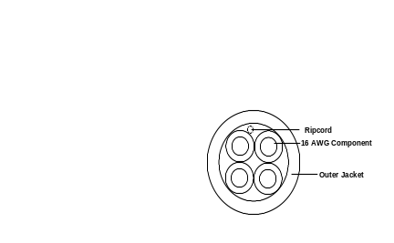 | 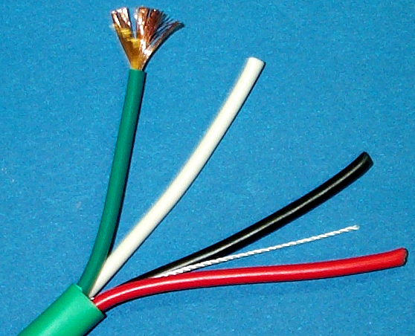
Physical Construction | Description
Component 1:  16 AWG 65/34 bare copper conductor  SR-PVC Insulation: .016-inch nominal thickness | Communications rated multi-conductor wire for control, instrumentation and distributed audio applications in accordance with NEC article 800.
 | Color Code
 | Black, Red, White, Green
 | Electrical Specifications
16 AWG:
DCR: 4.878 Ω per 1000 feet
Voltage: 300 Volts RMS
Temperature: -20°C to 75°C

Final assembly:  4 of component 1 twisted in a 4-inch lay  Nylon ripcord under the jacket.  PVC jacket: .025-inch nominal thickness  Final construction: .280-inch nominal OD  Product Print Legend: KO PLUS™ BY LIBERTY 16-4C-KO+ E190606-J (UL) 16 AWG TYPE CM 75°C --- C(UL) TYPE CMG 60°C  Sequential footmarks are applied in conjunction with the print legend. | Regulatory Specifications
(UL) rated CM
C(UL) rated CMG
EU RoHS 2002/95/EC Compliant since 08/26/2003
Specification Control | Product Information
Revision Date: 08/26/2003  Liberty Wire & Cable specifications are subject to change  without notice. Contact an account representative for current product specifications. Liberty Wire & Cable continuously strives to ensure product specifications are accurate and complete. All physical specifications are nominal. | Jacket Colors:  Light Green, White, Hot Pink, Gray  Packaging: 1000 foot reels, 500 foot reels, 500 ft pull box

